RIDER TECHNIC

Avem plăcerea de a vă trimite riderul tehnic al firmei noastre pentru evenimente ( zilele orașului, zilele comunei sau alte tipuri de evenimente). Acest rider poate fi modificat în funcție de necesități. Pentru mai multe informații puteți să ne contactați la nr. de telefon sus menționate.
Organizatorii vor asigura, locația, energia electrică, cazarea și masa pentru tecnicienilor (8 – 10 pers) pe durata evenimentului. Curent necesar minimum 100KW
Stage:

- Stage roof 12,5m x 10m x 8,6m Alustage
- Aluminium platform SCA03 12m x 10m

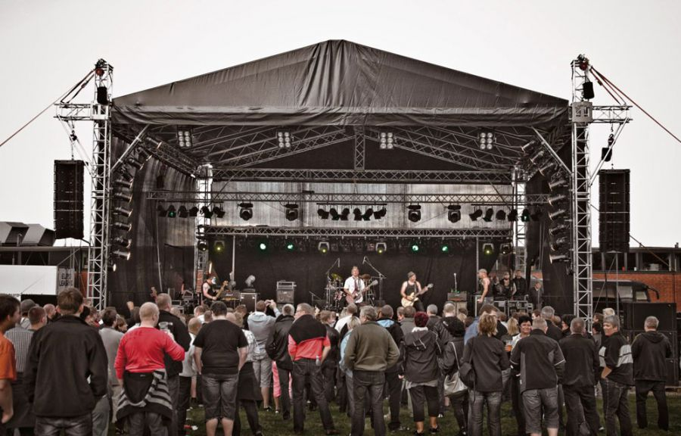
- Stage roof 8 m x 6 m x 6m Alustage
- Aluminium platform SCA03 8 m x 6 m
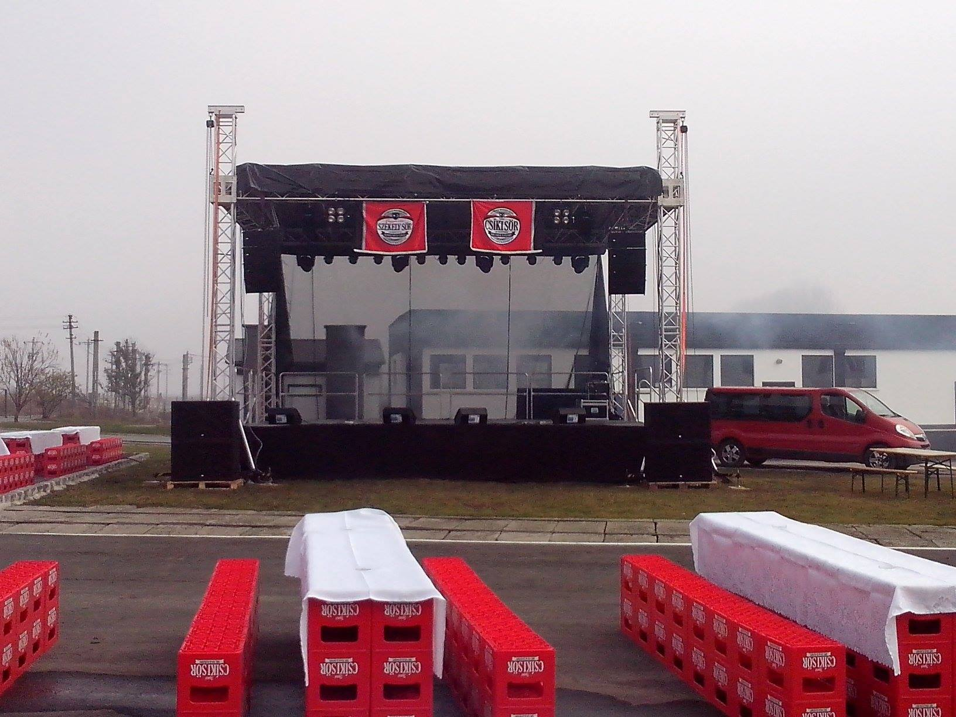

P.A. sound system:
RCF high definition, active, line array front audio system – 30,8KW (RMS), 61,6KW (peak)
- RCF D-LINE HDL20-A – Line array active top – 700W/1400W – 135 Db
- RCF 4PPRO 6001-A – Active 3 way top – 950W/1900W – 134 Db – center/side fill
- RCF D-LINE SUB 8006-AS – High power active subwoofer – 2500W/5000W – 141 Db
- RCF 4PRO 8003-AS – High power active subwoofer – 1000W/2000W - 134 Db – center/side fill
- RCF TT08 2 way active top – 750W/1500W – 134 Db – center
Mixing consoles:
- Midas PRO1 - 96Khz/40bit, 72 channel, 8 VCA, 16 AUX, digital mixing console – FOH/MONITOR (iPad network mixing)
Stagebox:
- Midas DL251 Digital stagebox, 48 Mic / Line, 16 Out, 19", 24 bit, 96 kHz
- Pro snake 95m CAT 5 Cable Drum
- Proel stagebox, 24 in/ 8 aut – 35m

Stage monitors:
- RCF NX 12-SMA ACTIVE COAXIAL STAGE MONITOR, 700W/1400W, 129 Db
- RCF ART 322-A, active 2 way stage monitor, 400W/800W
- RCF TT08 2 way active top – 750W/1500W – 134 Db
- RCF ART 322-A + RCF ART 705AS sub, 1100W/2200W (drums monitor set)
Backline:
- Laney IRT60H Ironheart 60W guitar head
- Laney IRT412 4x12 320W guitar cabinet
- Laney V300H guitar head
- Fender Rumble 350 Bass head – 350W
- Fender Rumble 410 - 4x10 Bass cabinet – 500W
Microphones:
- Whireless : Sennheiser XSw 35
- Shure: Beta 87A, Beta 58A, SM58, SM57
- Senheiser: e825
- Drumset: AKG D112, Shure Beta 91A,
- Senheiser e604,
- AKG: C1000
- Kick
Lighting:
- Moving heads: Futurelight Colorwash 575
- Moving heads spot:Futurelight MH860
- Moving heads spot: Stairville MH250S
- Par64 1000W
- Led Par64 RGB

EUROLITE Theatre Spot 2000, Fresnel schwarz

EUROLITE DMX Superstrobe 2700

Showtec Atmos 2000 Fogmachine DMX

EUROLITE DPX-610 MP DMX Dimmerpack
- Blinder 2500W
- Power distribuitors: BOTEX PSA-631 63A Stromverteiler, EUROLITE SB-1100 Unterverteilung 32A, EUROLITE SAB-616X Stromverteiler

Led Screen Display P-16 12 m2:

- Pixel Pitch – 16 mm
- Pixel composing – 2R1G1B/1R1G1B
- Changing frame frequency – 60Hz
- Display mode -1024 x 768

Regizie video:

Car de transmisie echipat cu:
- Camera video CANON XL H1 1 buc
- Camera video CANON XH A1 2 buc
- Camera cran 6,5 m 1 buc
- Mixer Video Tricaster Broadcast 6 chanale
- Monitor video Barco 6 buc
- Sistem de comunicare DATAVIDEO

Technician de sunet (hangmérnök): Bíró Zoltán, email: bbaxi@yahoo.com, tel: +40 752 193 810

Joseni SC MULTIMEDIA BAND SRL
Erdős András

